6 Invasion Games

With Innovative Targets

By Dr. John Byl

Follow/Subscribe with John on Twitter, Instagram, Pinterest, YouTube, or on his website

For 60+ more Invasion Games

- Yuki Ball

Objective:
- For one team to steal the other team’s flag

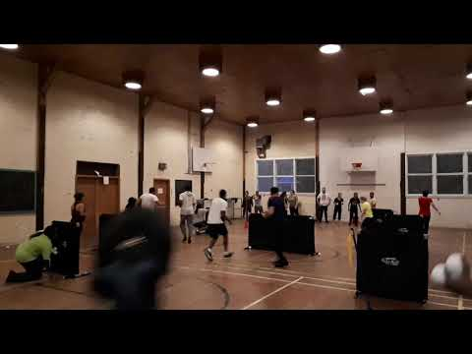

Fundamental Movement Skills:
- Locomotor
  - Dodge
  - Run
- Manipulative Send​
  - Throw​
- Manipulative Receive​​
  - Catch​
- Manipulative Retain​
  - Carry​

Equipment List:
- Yuki ball set

Setting Up:
- Set up the barricades, flags, and teams, as shown on the illustration below.
- Give each team a bucket of balls.
- Give each team their colour pinnies.

Instructions:
- On the signal to begin players 1-4 go on to the court and try to move forward to steal the other team’s flag.
- The remaining players must remain behind the end line.
- If a player beyond the end line gets hit by a “snowball” that player must do ten jumping jacks and then return to the back of their line. The player in the front of their team’s line now enters the playing area.
- The first team to successfully (not hit by a snowball) steal the other team’s flag and bring it past centre scores a point for their team.
- Reset and go again.

Notes and Questions for Understanding:
- Questions for understanding:
  - What are some of the best offensive strategies to consider? Positioning? Support?
  - What are some of the best defensive strategies to consider? Positioning? Support?
  - What might the above say about leadership?

- Dragon Tail Ultimate

Objective:
- Score points by catching a ball (or disc) in the end zone without losing your dragon tail.

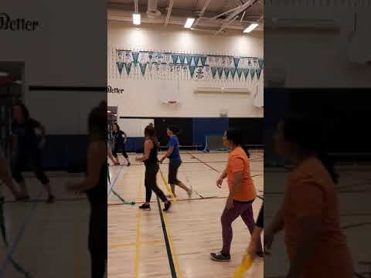

Fundamental Movement Skills:
- Locomotor
  - Dodge
  - Run
- Manipulative Send
  - Throw​
- Manipulative Receive​
  - Block
  - Catch​

Equipment List:
- One dragon tail per player—a different colour for each team
- One ball (or disc)

Setting Up:
- Use a volleyball court (or play outdoors on soccer field)—the end of the volleyball court is the end zone.
- Each team begins on their half of the court.

Instructions:
- Give the ball to a player from one of the two teams.
- Players with the ball can only pivot and cannot otherwise travel while holding the ball.
- Players pass the ball to each other in efforts to move the ball closer to their end zone.
- Players score by catching a ball in the end zone.
- When the ball lands on the floor or is intercepted or after a point is scored or if a ball carrier’s tail is removed, the other team gets possession of the ball.

Notes and Questions for Understanding:
- Safety
  - Make sure there is sufficient room in the end zone so players do not run into a wall.

3. Tri-Bound Five-Pass

Objective:
- After five passes, for a team to score a point by ultimately throwing a ball against the rebounder and having a teammate catch it.

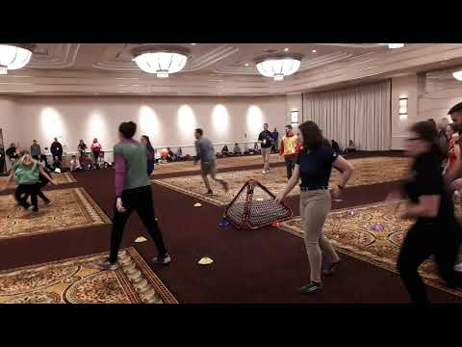

Fundamental Movement Skills:
- Locomotor
  - Dodge
  - Run
- Manipulative Send​
  - Throw​
- Manipulative Receive​
  - Block
  - Catch​

Equipment List:
- One Tri-Bound rebounder
- One ball

Setting Up:
- Place a Tri-Bound rebounder in the centre of the playing area.
- Divide approximately 14 to 24 players into two teams.
- Players are in a scattered position in the playing area.
- One player is given the ball.

Instructions:
- On the signal to begin players attempt to make five consecutive passes to their teammates.
- Players with the ball can only pivot and not otherwise move with the ball.
- Once a team has completed five consecutive passes, they may toss the ball against the rebounder and have a teammate attempt to catch the ball off of the rebounder bounce. A successful catch counts for one point.
- If a ball is intercepted by the other team or lands on the ground, the other team gets the ball.

Notes and Questions for Understanding:
- Questions for Understanding:
  - How can offensive teams most efficiently get five passes?
  - How can offensive teams most effectively get near the rebounder?
  - How can defensive teams most effectively prevent the other team from completing their passes?
  - How can the defensive team most effectively prevent the other team from throwing and catching a ball of the rebounder?
- Thanks to Gopher's Jordan Stolp for demonstrating this game at New York Shape 2019.

4. Basketball Controlled Dribble

Objective:
- To not lose contact of your ball when dribbling

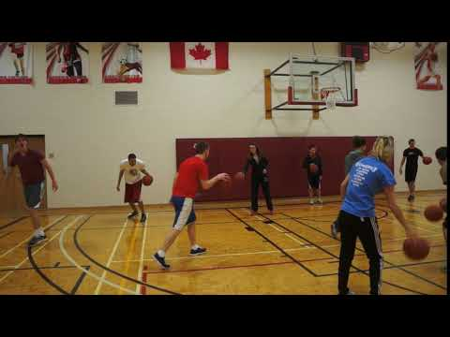

Fundamental Movement Skills:
- Manipulative Retain
  - Dribble

Equipment List:
- One basketball per player.

Setting Up:
- Players stand in a scattered formation inside a defined playing area.
- Each player holds one basketball.

Instructions:
- On the signal to begin all players begin dribbling their basketball and attempt to knock other players' balls away.
- When a player stops dribbling, goes outside the playing area, or loses their ball they start a line outside the playing area.
- When there are three players in line the first player rejoins the game.
- Continue for a preset time and determine who did not lose their ball during the entire game.

Notes and Questions for Understanding:
- Variation:
  - Use soccer balls and dribble with your feet, or ice hockey sticks and pucks...
- Questions for understanding:
  - What are techniques helpful in losing possession of your ball.​
  - What are techniques helpful in getting other players to lose their balls.

5. Basketball Robin’s Nest

Objective:
- To be the first team of three players to get three basketballs in your hoop

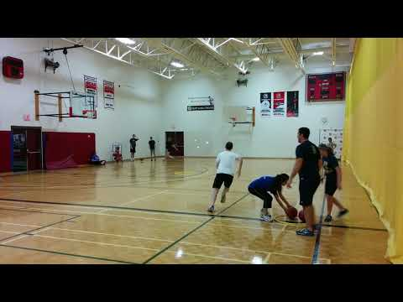

Fundamental Movement Skills:
- Locomotor
  - Run
- Manipulative Retain
  - Dribble

Equipment List:
- For four teams of three players:
  - 4-5 basketballs​
  - 5 hula hoops

Setting Up:
- Place 4 hula hoops in a square 10-15 paces apart from each other.
- Place one hula hoop in the middle of the square.
- Place the basketballs in the middle hula hoop.
- Teams of three players each stand behind their hula hoop.

Instructions:
- On the leader's signal to begin the first player from each team runs to the middle hoop, selects a basketball, and dribbles it back to their team.
- One the ball has been placed in the team's hoop the next player goes to retrieve a ball.
- If there are no more balls in the middle then teams get balls from the other team hoops.
- The first team to get three balls in their hoop is the winner.

Notes and Questions for Understanding:
- Questions for understanding:
  - What technique is best use to dribble the basketball quickly and with control?
  - What are the best strategies to win at this game?
- Source: Modification from CIRA Ontario’s Everybody Move, Robin Nest

6. Hoop Toss from Scooters

Objective:
- For teams to score by tossing a ball through a hanging hoop

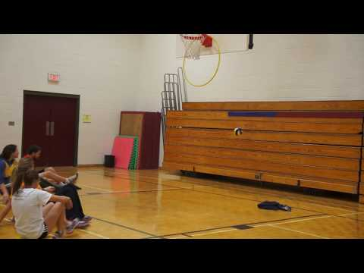

Fundamental Movement Skills:
- Manipulative Send
  - Throw
- Manipulative Receive
  - Catch

Equipment List:
- Two hula hoops
- One ball
- One scooter per player

Setting Up:
- Set up two teams of 5-8 players on a small basketball court
- Hang a hula hoop on each basketball goal at either end
- Give one team the ball.

Instructions:
- On the leader's signal to begin players attempt to pass the ball to their teammates in efforts to move closer to their goal and shoot the ball through the hula hoop.
- Players may not move with their scooter when in possession of the ball.
- If there is an incomplete pass the other teams take posssession of the ball.

Notes and Questions for Understanding:
- Questions for Understanding:
  - What are keys to successfully moving the ball towards the hula hoop and scoring?
  - What are keys to successfully preventing the offensive team from passing and scoring?
  - How does riding on scooters change your experience?

