Ace Chase

Objective: Be the first team to score 11 points
View at:
Equipment at: https://www.gophersport.com/unassigned/ace-chase
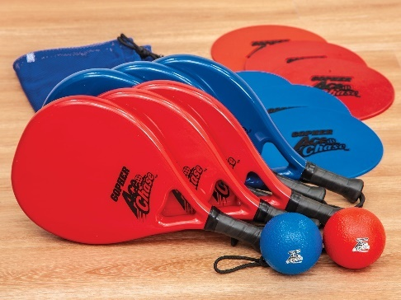
- Tape
Setup:
- Using floor tape, create a hegagon as shown on the diagram—the cross pieces are about 8-9 steps long.
- Place a poly spot near the back and in the middle of each triangle.
- Six player each stand in a triangle, each holding a paddle (three players are on one team and three players stand opposite on the other team).
- One player holds a ball

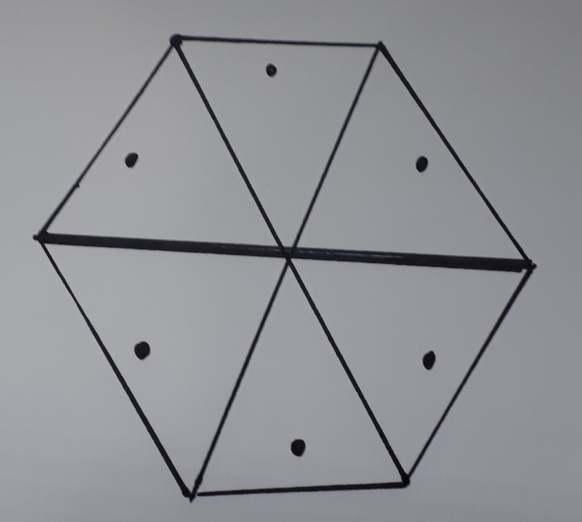

Instructions:

- The player with the ball bounces the ball off the floor and hits the ball up into one of the opposing triangles.
- The ball must bounce in a triangle before the player, whose triangle it is, returns it an upward motion to the opposition side; or to a teammate (as each team is permitted three hits before it must be returned).
- One point is scored if a team is:
  - Unnable to return it to the opponents side.
  - The wrong player plays the ball
  - A ball is hit out-of-bounds.
- Three points are scored if the ball hits one of the poly spots.
- Play to 21.
Variation:
- A couple extra players can stand outside the hexagon and if a player makes a mistake they take their place.
Questions for Understanding:
- Offensively, what are the best tactics to make it difficult for the defense to return the ball?
- Defensively, what are the best tactics to be able to receive the ball most effectively?

