5 Bosu Ball:

Familiarization Challenges
By Dr. John Byl

Follow/Subscribe with John on Twitter, Instagram, Pinterest, YouTube, or on his website

For 30+ Bosu Challenges

- Side Planks

Objective:
- For players to complete a set number of side planks or complete side planks within a set time limit.

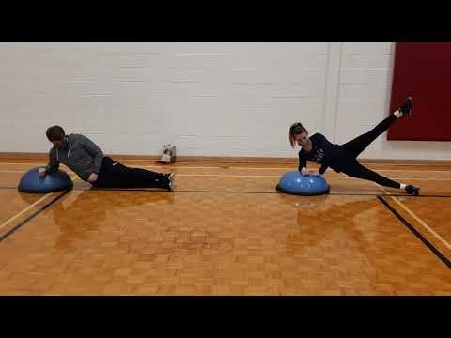

Fundamental Movement Skills:
- Non-locomotor
  - Balance
  - Side Plank

Equipment List:
- One Bosu ball

Setting Up:
- Players lie on their side with one leg above the other, and forearm and other hand on the Bosu ball.

Instructions:
- Players then pull their hips up so that their bodies are erect.
- Then put hand up in the air and wave.
- Hold for 20 seconds.
- After desired repetitions repeat on the other side of the body.

Notes and Questions for Understanding:
- Variations:
  - Stay in up-position, and perform a crunch with upper elbow and knee.
  - Before going down do one crunch with upper elbow and knee.
- Question for Understanding:
  - o Which muscles do you think you are developing?

2. Gluteus Bridge

Objective:
- For players to complete a set number of bridges.

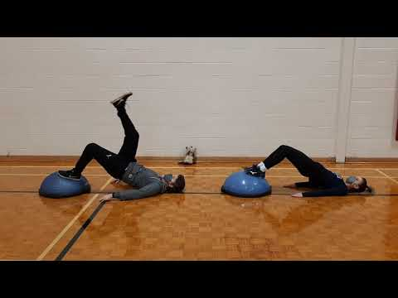

Fundamental Movement Skills:
- Non-locomotor
  - Balance
  - Bridge

Equipment List:
- One Bosu ball

Setting Up:
- Players lay on their back with their feet resting on top of a Bosu ball, with legs at 90 degrees at the knees.

Instructions:
- Players press through their feet to lift their hip up forming a straight line from the players’ shoulders to knees.
- Hold for 10 seconds and descend slowly.

Notes and Questions for Understanding:
- Variation:
  - Complete this exercise but with one leg pointing straight up, not bending at 90 degrees.
- Question for Understanding:
  - Which muscles do you think are being trained with this exercise?

3. Split Squats

Objective:
- For players to complete a set number of split-squats.

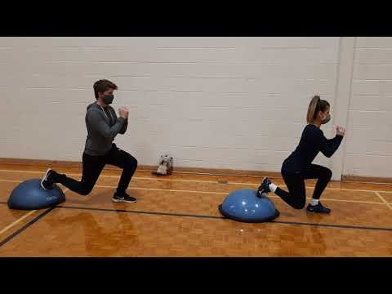

Fundamental Movement Skills:
- Non-locomotor
  - Balance

Equipment List:
- One Bosu ball

Setting Up:
- Players stand with one foot on the ground with the Bosu ball behind them.
- Players then bring one foot backwards to rest on the Bosu ball with their toes or ball of feet.
- Hands are clasped in front of face (or holding a ball in front of face).

Instructions:
- On the signal to begin, players lower their body so that the knee (of the leg resting on the ball) nears the ground and the other leg does not go past 90 degrees. This is one repetition.
- Complete a set number of repetitions.
- Do the same but with opposite feet forward and backwards.

Notes and Questions for Understanding:
- Question for Understanding:
  - What techniques help players to retain balance in this challenge?

4. Stand and Stork Stand

Objective:
- For players to retain balance on a Bosu ball.

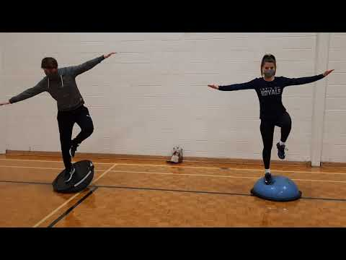

Fundamental Movement Skills:
- Non-locomotor
- Balance

Equipment List:
- One Bosu ball

Setting Up:
- Players stand in a balanced position on an upright Bosu ball.

Instructions:
- On the signal to begin, players retain their balance on the ball for as long as they can or for a specified time.

Notes and Questions for Understanding:
- Variations:
  - Players do the same but standing on one leg (be sure to test on each leg).
  - Flip Bosu ball upside down to make it more challenging.
- Question for Understanding:
  - What helps players retain balance when on the Bosu ball?

5. Step Up with High Knee

Objective:
- For players to step up on the Bosu ball with one leg and lift the other knee.

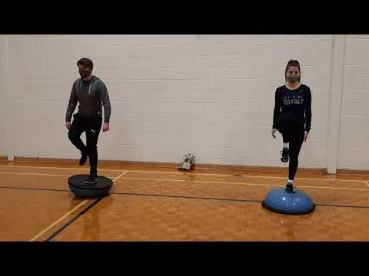

Fundamental Movement Skills:
- Non-locomotor
  - Balance

Equipment List:
- One Bosu ball

Setting Up:
- Players stand directly in front of a Bosu ball.

Instructions:
- Players then step up on the Bosu ball with one leg and lift the other knee to a high position and then go back to start.
- The next step players step up with the opposite leg.
- The above completes one repetition.

Notes and Questions for Understanding:
- Variation:
  - Flip Bosu ball and use upside-down.
- Questions for Understanding:
  - What helps players retain balance when on the Bosu ball? How might arms play a role?
  - Is it easier stepping up with one leg than the other? Why?
  - Is it easier the Bosu ball right side up or upside-down? Why?

